Applying Codes in Forms

Calculations In Simple Form 2

Calculate Age if both Age and DOB is from simple form 2

Calculate Sum Of Field Without Array 2

Currency Addition 3

Sum of fields in survey 3

Average of amount 4

Calculations Inside Data grid 4

Calculate amount from data grid 4

Length For Data grid 4

Additions of the fields inside grid in each row 5

Date Calculations Codes 6

Calculated total days between 2 dates 6

Calculate days from current date 6

Advance Conditional Codes 7

More than 1 condition in a field 7

Hide Panel From Public Form 7

Content conditional code 8

Edit Grid Codes 8

When You want to show all Fields in edit grid or show fields in more than one line 8

Select Boxes values showing in editgrid 10

When you want to show fields in one row 11

CSS Codes 12

Adding Border 12

Code Changing Font-family in entire form 13

Role Based Section show/hide 14

**For Single Role** 15

For multiple Roles 15

# **Calculations In Simple Form**

### Calculate Age if both Age and DOB is from simple form

if(typeof row.dob != "undefined" ){

let DOB = row.dob;

if (DOB !== "") {

var selectedYear = new Date(DOB);

var ageDifMs = Date.now() - selectedYear.getTime();

var ageDate = new Date(ageDifMs);

value = Math.abs(ageDate.getUTCFullYear() - 1970);

}

else {

value = 0;

}

}

### Calculate Sum Of Field Without Array

value = 0;

if((data.Container.Select_1 * 1) > 0){

value += (data.Container.Select_1 * 1);

}

if((data.Container.Select_2 * 1) > 0){

value += (data.Container.Select_2 * 1);}

### Currency Addition

value = 0;

if((data.Container.Brief_Resilience_Scale_BRS.I_tend_to_bounce_back_quickly_after_hard_time_ * 1) > 0){

value += (data.Container.Brief_Resilience_Scale_BRS.I_tend_to_bounce_back_quickly_after_hard_time_ * 1);

}

if((data.Container.Brief_Resilience_Scale_BRS.I_have_a_hard_time_making_it_through__tre__ful_event_ * 1) > 0){

value += (data.Container.Brief_Resilience_Scale_BRS.I_have_a_hard_time_making_it_through__tre__ful_event_ * 1);

}

### Sum of fields in survey

value = 0;

if((data.Container.Brief_Resilience_Scale_BRS.I_tend_to_bounce_back_quickly_after_hard_time_ * 1) > 0){

value += (data.Container.Brief_Resilience_Scale_BRS.I_tend_to_bounce_back_quickly_after_hard_time_ * 1);

}

if((data.Container.Brief_Resilience_Scale_BRS.I_have_a_hard_time_making_it_through__tre__ful_event_ * 1) > 0){

value += (data.Container.Brief_Resilience_Scale_BRS.I_have_a_hard_time_making_it_through__tre__ful_event_ * 1);

}

### Average of amount

value= 0;

let num1 = data.container.budget18;

let num2 = data.container.budget20;

let num3 = data.container.budget69;

let avg = (num1 + num2 + num3) / 3

value = avg;

# **Calculations Inside Data grid**

### Calculate amount from data grid

let sum = 0;

let a = data.Container.Data_Grid1.length;

for (let i = 0; i < a; i++)

{

if((data.Container.Data_Grid1[i].Amount * 1) > 0){

sum += data.Container.Data_Grid1[i].Amount;

}

}

value = sum;

### Length For Data grid

value = 0;

let a = data.Container.Data_Grid.length;

for (let i = 0; i < a; i++) {

if ((data.Container.Data_Grid[i].Household_Member_Names) && data.Container.Data_Grid[i].Relationship_to_HOH) {

value += 1;}

}

### Additions of the fields inside grid in each row

value = 0;

let sum = 0;

let num1 = row.A_Employment_or_Wages;

let num2= row.B_Soc_Security_Pensions;

let num3 = row.C_Annual_amount_of_income_received_;

let num4 = row.D_Total_Income_from_Assets;

let num5 = row.E_Other_Income;

if ((num1 *1) > 0){

sum = sum + num1;

}

if ((num2 *1) > 0){

sum = sum + num2;

}

if ((num3 *1) > 0){

sum = sum + num3;

}

if ((num4 *1) > 0){

sum = sum + num4;

}

if ((num5 *1) > 0){

sum = sum + num5;

}

value = sum;

# **Date Calculations Codes**

### Calculated total days between 2 dates

let days = 0;

var admissionDate = "";

var dischargeDate = "";

if (!!row.checkIn){

admissionDate = new Date(row.checkIn);

admissionDate = admissionDate.getTime();

}

else{

value = 0;

return value;

}

if (!!row.checkOut){

dischargeDate = new Date(row.checkOut);

dischargeDate = dischargeDate.getTime();

}

else {

dischargeDate = Date.now();

}

const oneDay = 24 * 60 * 60 * 1000;

const diffDays = Math.round(Math.abs((dischargeDate - admissionDate) / oneDay));

value = diffDays;

### Calculate days from current date

if (typeof row.TransDate !== "undefined") {

let DOB = row.TransDate;

if (DOB !== "") {

var selectedDate = new Date(DOB);

var currentDate = new Date();

var oneDay = 24 * 60 * 60 * 1000;

var diffDays = Math.round(Math.abs((currentDate - selectedDate) / oneDay));

value = diffDays;

} else {

value = 0;

}}

# **Advance Conditional Codes**

### More than 1 condition in a field

show = false;

var dependsOnValue1 = "Own_apartmenthousetrailer";

var dependsOnValue2 = "With_a_family_member_or_friend";

if(data.Container.Container1.Where_did_you_stay_last_night == dependsOnValue1){

show = isHidden;

}

if(data.Container.Container1.Where_did_you_stay_last_night == dependsOnValue2){

show = isHidden;

}

### Hide Panel From Public Form

show = false;

if (typeof window.token != "undefined" && window.token !== "" && !/publicform/i.test(window.location.href)) {  
  show = true;  
}

if (window.location.href.indexOf("MobileCaseDetails") > -1) {

show = true;

}

### Content conditional code

show = false;

if(data.Container.Total_Scoring === 0){

show = true;

}

# **Edit Grid Codes**

### When You want to show all Fields in edit grid or show fields in more than one line

**Header**

<div class="row">

<div class="col-md-4"> <b>Task/Support Grid 1</b> </div>

<div class="col-md-4"> <b></b></div>

<div class="col-md-2"> <b></b> </div>

</div>

**Row**

<div class="container">

<div class="row">

<div class="col-sm-4">

<b>Service Type:</b>{{ row.ServiceType }}</b>

</div>

<div class="col-sm-4">

<b>Start Date:</b>{{moment(row.StartDate).format("MM-DD-YYYY") }}

</div>

<div class="col-sm-4">

<b>End Date: </b>{{ moment(row.EndDate).format("MM-DD-YYYY") }}

</div>

</div>

<br />

<br />

<div class="row">

<div class="col-sm-4">

<b>Number Units:</b>{{ row.NumberUnits2 }}

</div>

<div class="col-sm-4">

<b>Hours Per Week: </b>{{ row.HoursPerWeek2 }}

</div>

<div class="col-sm-4">

<b>Cost Per Unit: </b>{{ row.CostPerUnit2 }}

</div>

</div>

<br />

<br />

<div class="row">

<div class="col-sm-4">

<b>Number Previous Auths:</b>{{row.NumberPreviousAuths1 }}

</div>

<div class="col-sm-4">

<b>Last Authorization?:</b> {{ row.LastAuth1 }}

</div>

<div class="col-sm-4">

<b>EstimatedTotalCost:</b>{{ row.EstimatedTotalCost }}

</div>

{% if (!instance.options.readOnly && !instance.originalComponent.disabled) {

%}

<div class="col-sm-4">

<div class="btn-group pull-right">

<button class="btn btn-default btn-light btn-sm editRow">

<i class="{{ iconClass('edit') }}"></i>

</button>

{% if (!instance.hasRemoveButtons || instance.hasRemoveButtons()) { %}

<button class="btn btn-danger btn-sm removeRow">

<i class="{{ iconClass('trash') }}"></i>

</button>

{% } %}

</div>

</div>

{% } %}

</div>

</div>

# **Select Boxes values showing in editgrid**

<div class="row">

  <div class="col-sm-12">

      <b>Bedding Needed:</b>

      {{ Object.keys(row.Bedding_needed)

          .filter(key => row.Bedding_needed[key] === true)

          .map(key => key.replace(/_/g, ' '))

          .join(', ') }}

  </div>

</div>

<br />

<br />

**Header Template**

<div class="row">

{% util.eachComponent(components, function(component) { %}

{% if (displayValue(component)) { %}

<div class="col-sm-2"></div>

{% } %}

{% }) %}

</div>

**Row Template**

<div class="row">

{% util.eachComponent(components, function(component) { %}

{% if (displayValue(component)) { %}

<div class="col-sm-6">

<b> {{ t(component.label) }}</b>

{{ isVisibleInRow(component) ? getView(component, row[component.key]) : ''}}

</div>

<br />

<br />

{% } %}

<br />

<br />

{% }) %}

<!-- Render Edit and Remove buttons if form is not read-only and not disabled -->

{% if (!instance.options.readOnly && !instance.disabled) { %}

<div class="col-sm-2">

<div class="btn-group pull-right">

<button class="btn btn-default btn-light btn-sm editRow"><i class="{{ iconClass('edit') }}"></i></button>

{% if (!instance.hasRemoveButtons || instance.hasRemoveButtons()) { %}

<button class="btn btn-danger btn-sm removeRow"><i class="{{ iconClass('trash') }}"></i></button>

{% } %}

</div>

</div>

{% } %}

</div>

### When you want to show fields in one row

**Header**

<div class="row">

<div class="col-md-4"> <b>Household Member Name</b> </div>

<div class="col-md-4"> <b>Relationship</b> </div>

<div class="col-md-2"> <b>DOB</b> </div>

</div>

**Row**

<div class="row">

<div class="col-md-4">{{ row.name }}</div>

<div class="col-md-4">{{ row.relationshipToTheVictim }}</div>

<div class="col-md-2">{{ row.dob }}</div>

{% if (!instance.options.readOnly && !instance.originalComponent.disabled) { %}

<div class="col-sm-12">

<div class="btn-group pull-right">

<button class="btn btn-default btn-light btn-sm editRow"><i class="{{ iconClass('edit') }}"></i></button>

{% if (!instance.hasRemoveButtons || instance.hasRemoveButtons()) { %}

<button class="btn btn-danger btn-sm removeRow"><i class="{{ iconClass('trash') }}"></i></button>

{% } %}

</div>

</div>

{% } %}

</div>

# **CSS Codes**

### Adding Border

Follow these steps

* Add html component
* Inside display tab in html tag field write style
* In Content Add code

.lineLayout {

border: 1px solid black;

}

* Add Another Html component
* Inside display tab in html tag field write hr
* Inside display tab in CSS Class field write class name (lineLayout)

### Code Changing Font-family in entire form

1. Drag and drop HTML Element Component from Layout at the top of you form inside Container.

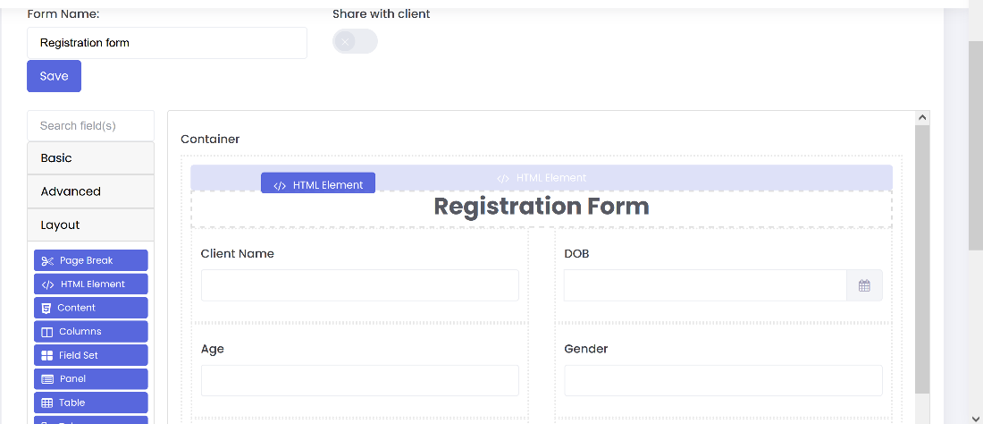

1. In Display tab write “style” in HTML Tag field.
2. Paste the following code inside the Content area of HTML Element Component and save it.

.fontChange .col-form-label {

font-family: Raleway;

}

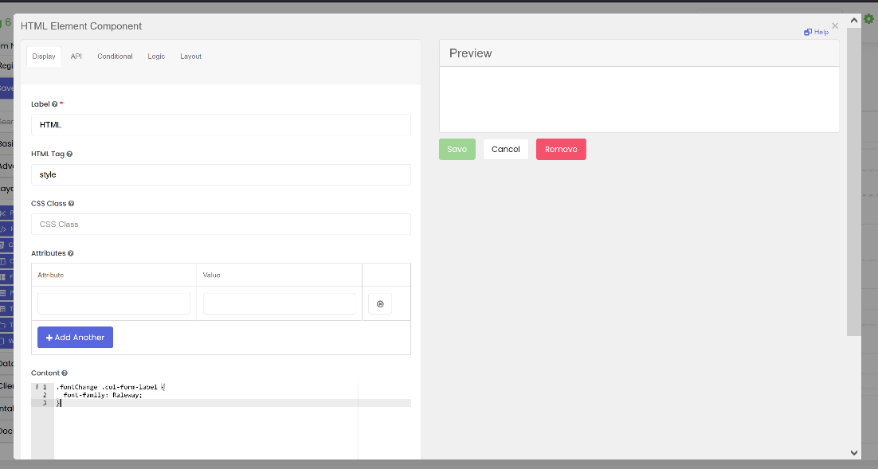

1. Edit your Form Container component.
2. In Display tab write “fontChange” in Custom CSS Class field and save it.

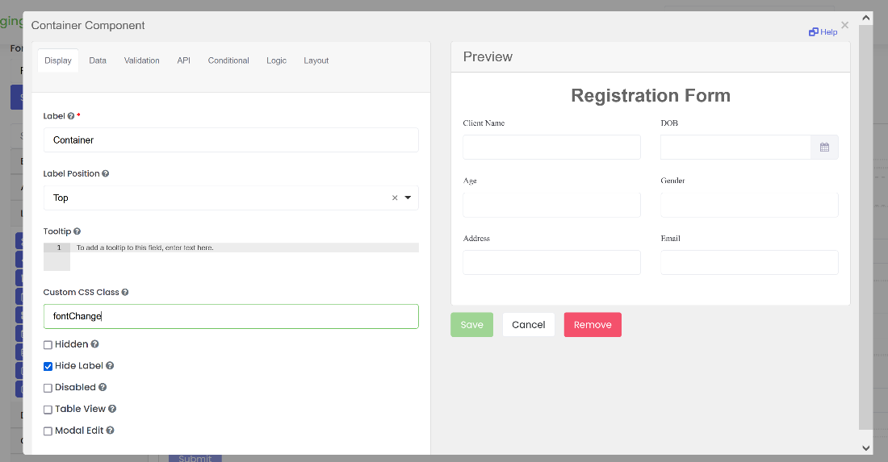

1. Save the form you will see that the font-family of all labels inside that form has changed.

# **Role Based Section show/hide**

 We need to turn on the below system from system settings. It is by default NO. To render the role base condition code, we first need to tern it to "Yes".  
   
   
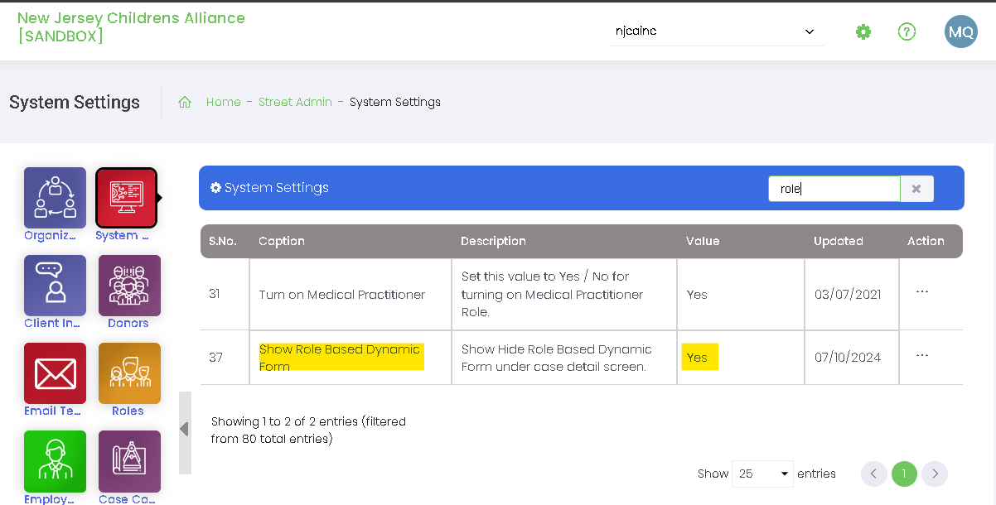

this code will work on Add Case and Case Detail

### **For Single Role**

if($("#currentUserRolesForForm").val() == "ROLENAMEHERE") {

show = true;

} else {

show = false;

}

### For multiple Roles

if($("#currentUserRolesForForm").val() && ($("#currentUserRolesForForm").val().split(",").includes(ROLENAME1) || $("#currentUserRolesForForm").val().split(",").includes(ROLENAME2))) {

show = true;

} else {

show = false;

}

var allowedRoles = ['Case Manager', 'Counselor', 'SCR', 'SCC'];

let userRoles = $('#currentUserRolesForForm').val();

if (typeof userRoles === 'string' || window.location.pathname.toLowerCase().includes("restrictedintake")) {

show = allowedRoles.some(role => userRoles.includes(role)) || window.location.pathname.toLowerCase().includes("restrictedintake");

}

else{

show = false;

}